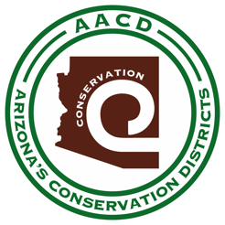
REDINGTON NATURAL RESOURCE CONSERVATION DISTRICT

Conserve * Grow * Live

Notice of a 2nd Quarter Redington NRCD & Education Center Meeting
January 30, 2024 at 4:00P.M.
Notice is hereby given to the members of the Redington NRCD and to the general public that the Board of Supervisors will hold a Regular Meeting open to the public on January 30, 2024 via teleconference

Teleconference Meeting

Dial in: (267) 807-9598
Passcode: 645-264-651

Welcome

Roll Call:

Minutes

Action Items:
- Appoint 3 members to be the election committee
- AACD/Redington Agreement
- Bank Accounts
- Education Center Funding

Set Next Meeting

Adjourn

Meeting Notice & Agenda Posted physically at 23805 E. Redfield Canyon Rd. Benson, AZ 85602
& Electronically on WWW.AACD1944.com/Redington

